Notice to Mariners No 02/25

ARDERSIER PORT REDEVELOPMENT CHARTED DEPTHS

Mariners are reminded that Ardersier Port and its approaches have not been dredged for many years and that significant siltation has occurred since the harbour area was last operational.
Major dredging works are planned for 2025, following which charts will be updated. Until such time Mariners are advised to exercise caution when transiting through the area under Ardersier Port jurisdiction, particularly in relation to depths, which may not be as currently charted.
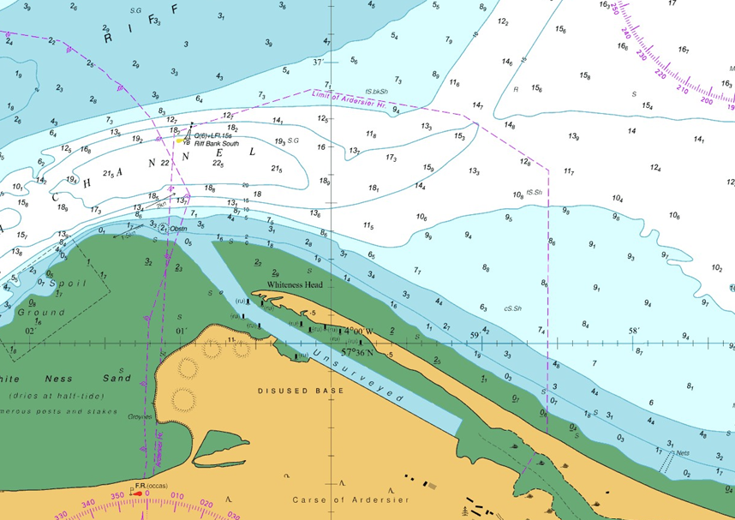
Mariners are advised to plan their passages accordingly to ensure that they have ample under keel clearance. Further information can be found on the Haventus website or by contacting Ardersier Port on 01667 656000 www.haventus.com

Ron Bailey
Interim Harbour Master

